**DEDAN KIMATHI UNIVERSITY OF TECHNOLOGY**

**SCHOOL:COMPUTER SCIENCE AND IT**

**DEPARTMENT: INFORMATION TECHNOLOGY**

**NAME: NJOROGE GIDEON KORI.**

**REG NO:C025-01-1236/2019.**

**UNIT:SIMULATION AND MODELLING**

**TAST:MAKE UP CAT**

Simulate a queue system for a car wash with three slots (car washing points) given that each car washer takes 15 minutes washing the car, 10 minutes drying the car and 7 minutes spraying the internet of the car. Assume that the cars are arriving at the car wash at intervals of 35 minutes. Determine (through calculations) whether the car wash business is beneficial to the owner.

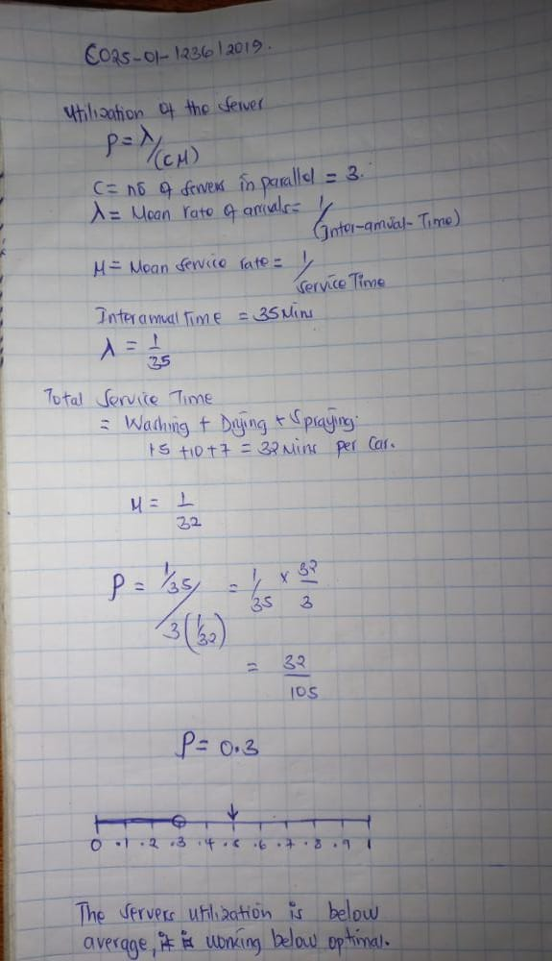washers utilization is below optimal, it means that most of the time the servers are idle which is not good for business hence the business is not beneficial to the owner